1/9/2022
SHUBHANK KATAREY
PGPDSBA 2021-2022
Financial and Risk Analytics
Milestone 1

FINANCIAL AND RISK ANALYTICS (MILESTONE 1)

PROBLEM STATEMENT
Businesses or companies can fall prey to default if they are not able to keep up their debt obligations. Defaults will lead to a lower credit rating for the company which in turn reduces its chances of getting credit in the future and may have to pay higher interests on existing debts as well as any new obligations. From an investor's point of view, he would want to invest in a company if it is capable of handling its financial obligations, can grow quickly, and is able to manage the growth scale.
A balance sheet is a financial statement of a company that provides a snapshot of what a company owns, owes, and the amount invested by the shareholders. Thus, it is an important tool that helps evaluate the performance of a business.
Data that is available includes information from the financial statement of the companies for the previous year (2015). Also, information about the Net worth of the company in the following year (2016) is provided which can be used to drive the labeled field.
NOTE: In the dataset, there is no target column. So, we need to create it as per the below given condition.
Dependent variable - We need to create a default variable that should take the value of 1 when net worth next year is negative & 0 when net worth next year is positive.

ABOUT THE DATA
1. Let’s have a look at the dataset.

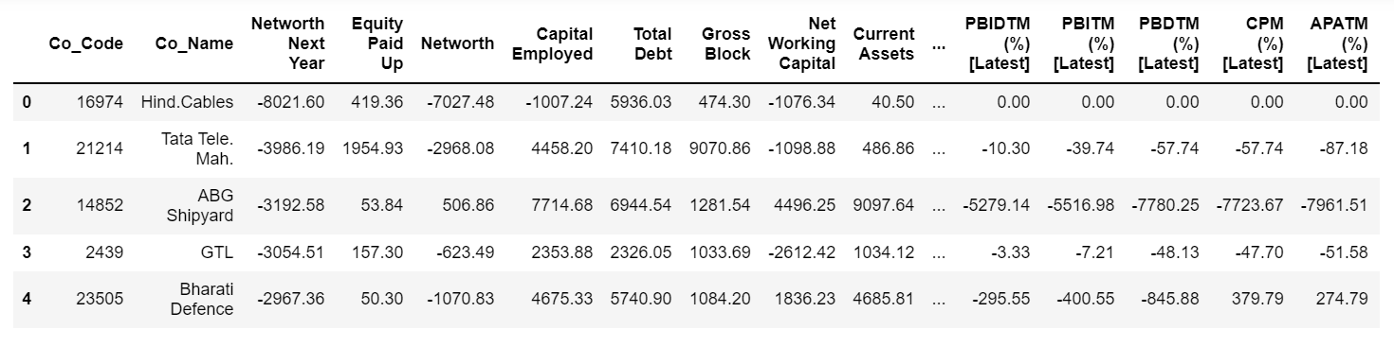
DATA DICTIONARY

# | Field Name | Description
1 | Co_Code | Company Code
2 | Co_Name | Company Name
3 | Networth Next Year | Value of a company as on 2016 - Next Year(difference between the value of total assets and total liabilities)
4 | Equity Paid Up | Amount that has been received by the company through the issue of shares to the shareholders
5 | Networth | Value of a company as on 2015 - Current Year
6 | Capital Employed | Total amount of capital used for the acquisition of profits by a company
7 | Total Debt | The sum of money borrowed by the company and is due to be paid
8 | Gross Block | Total value of all of the assets that a company owns
9 | Net Working Capital | The difference between a company's current assets (cash, accounts receivable, inventories of raw materials and finished goods) and its current liabilities (accounts payable).
10 | Current Assets | All the assets of a company that are expected to be sold or used as a result of standard business operations over the next year.
11 | Current Liabilities and Provisions | Short-term financial obligations that are due within one year (includes amount that is set aside cover a future liability)
12 | Total Assets/Liabilities | Ratio of total assets to liabailities of the company
13 | Gross Sales | The grand total of sale transactions within the accounting period
14 | Net Sales | Gross sales minus returns, allowances, and discounts
15 | Other Income | Income realized from non-business activities (e.g. sale of long term asset)
16 | Value Of Output | Product of physical output of goods and services produced by company and its market price
17 | Cost of Production | Costs incurred by a business from manufacturing a product or providing a service
18 | Selling Cost | Costs which are made to create the demand for the product (advertising expenditures, packaging and styling, salaries, commissions and travelling expenses of sales personnel, and the cost of shops and showrooms)
19 | PBIDT | Profit Before Interest, Depreciation & Taxes
20 | PBDT | Profit Before Depreciation and Tax
21 | PBIT | Profit before interest and taxes
22 | PBT | Profit before tax
23 | PAT | Profit After Tax
24 | Adjusted PAT | Adjusted profit is the best estimate of the true profit
26 | CP | Commercial paper, a short-term debt instrument to meet short-term liabilities.
27 | Revenue earnings in forex | Revenue earned in foreign currency
28 | Revenue expenses in forex | Expenses due to foreign currency transactions
29 | Capital expenses in forex | Long term investment in forex
30 | Book Value (Unit Curr) | Net asset value
31 | Book Value (Adj.) (Unit Curr) | Book value adjusted to reflect asset's true fair market value
32 | Market Capitalization | Product of the total number of a company's outstanding shares and the current market price of one share
33 | CEPS (annualized) (Unit Curr) | Cash Earnings per Share, profitability ratio that measures the financial performance of a company by calculating cash flows on a per share basis
34 | Cash Flow From Operating Activities | Use of cash from ongoing regular business activities
35 | Cash Flow From Investing Activities | Cash used in the purchase of non-current assets–or long-term assets– that will deliver value in the future
36 | Cash Flow From Financing Activities | Net flows of cash that are used to fund the company (transactions involving debt, equity, and dividends)
37 | ROG-Net Worth (%) | Rate of Growth - Networth
38 | ROG-Capital Employed (%) | Rate of Growth - Capital Employed
39 | ROG-Gross Block (%) | Rate of Growth - Gross Block
40 | ROG-Gross Sales (%) | Rate of Growth - Gross Sales
41 | ROG-Net Sales (%) | Rate of Growth - Net Sales
42 | ROG-Cost of Production (%) | Rate of Growth - Cost of Production
43 | ROG-Total Assets (%) | Rate of Growth - Total Assets
44 | ROG-PBIDT (%) | Rate of Growth- PBIDT
45 | ROG-PBDT (%) | Rate of Growth- PBDT
46 | ROG-PBIT (%) | Rate of Growth- PBIT
47 | ROG-PBT (%) | Rate of Growth- PBT
48 | ROG-PAT (%) | Rate of Growth- PAT
49 | ROG-CP (%) | Rate of Growth- CP
50 | ROG-Revenue earnings in forex (%) | Rate of Growth - Revenue earnings in forex
51 | ROG-Revenue expenses in forex (%) | Rate of Growth - Revenue expenses in forex
52 | ROG-Market Capitalization (%) | Rate of Growth - Market Capitalization
53 | Current Ratio[Latest] | Liquidity ratio, company's ability to pay short-term obligations or those due within one year
54 | Fixed Assets Ratio[Latest] | Solvency ratio, the capacity of a company to discharge its obligations towards long-term lenders indicating
55 | Inventory Ratio[Latest] | Activity ratio, specifies the number of times the stock or inventory has been replaced and sold by the company
56 | Debtors Ratio[Latest] | Measures how quickly cash debtors are paying back to the company
57 | Total Asset Turnover Ratio[Latest] | The value of a company's revenues relative to the value of its assets
58 | Interest Cover Ratio[Latest] | Determines how easily a company can pay interest on its outstanding debt
59 | PBIDTM (%)[Latest] | Profit before Interest Depreciation and Tax Margin
60 | PBITM (%)[Latest] | Profit Before Interest Tax Margin
61 | PBDTM (%)[Latest] | Profit Before Depreciation Tax Margin
62 | CPM (%)[Latest] | Cost per thousand (advertising cost)
63 | APATM (%)[Latest] | After tax profit margin
64 | Debtors Velocity (Days) | Average days required for receiving the payments
65 | Creditors Velocity (Days) | Average number of days company takes to pay suppliers
66 | Inventory Velocity (Days) | Average number of days the company needs to turn its inventory into sales
67 | Value of Output/Total Assets | Ratio of Value of Output (market value) to Total Assets
68 | Value of Output/Gross Block | Ratio of Value of Output (market value) to Gross Block

2. Shape: There are 3586 rows and 67 columns in the dataset.
3. Duplicates: There are no duplicates available.
4. Five number summary:
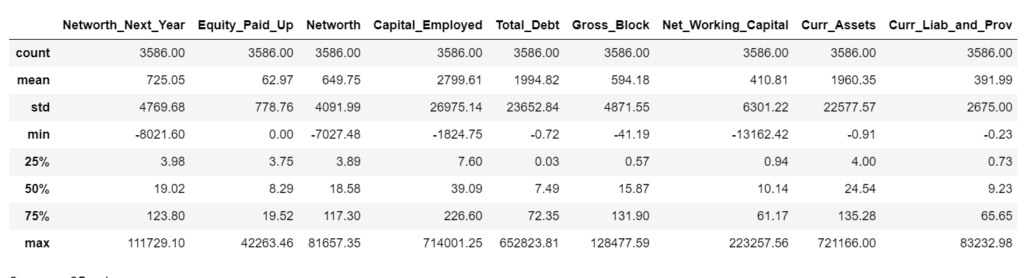

INFO ABOUT THE DATASET
There are total 3586 entries starting from 0 to 3585.
There are total 67 columns starting from 0 to 66, excluding target variable.
We have renamed the columns for better readability and for better understanding.
Available data types are:
Object – 1
Int64 – 3
Float64 – 63
Let’s have a look at the info in the form of table.

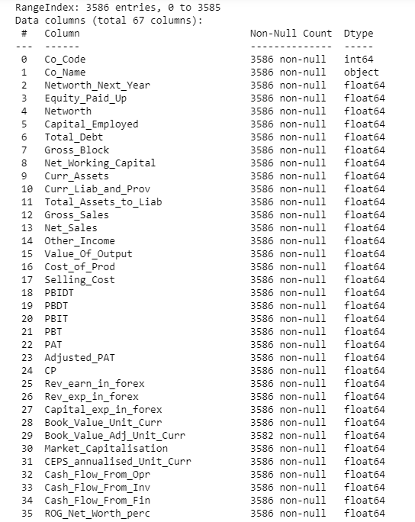
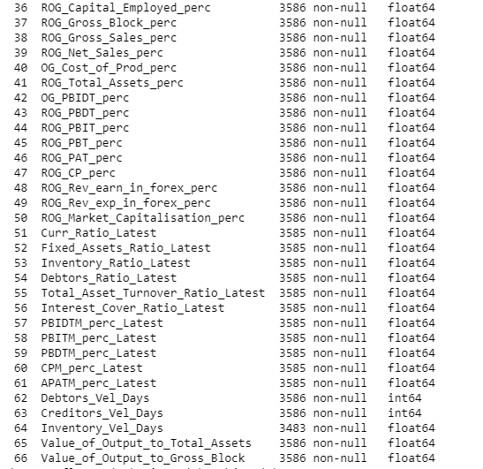

DEPENDENT VARIABLE
We need to create a default variable that should take the value of 1 when net worth next year is negative & 0 when net worth next year is positive.
So after considering the column name ‘Networth_Next_Year’ we have created the column named, ‘Default’ which has values 0 and 1.
For verification, let’s have a look at the head and tail of the columns ‘Networth_Next_Year’ and ‘Default’.
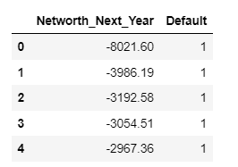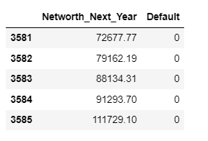
0 means the company has the ‘Networth_Next_Year’ is positive.
1 means that the company has the ‘Networth_Next_Year’ is negative.
Then we have done the value counts of Default variable.
We got the below results:
Count of 1 (Defaulted) is 387 and Count of 0 (Non-Default) is 3199.
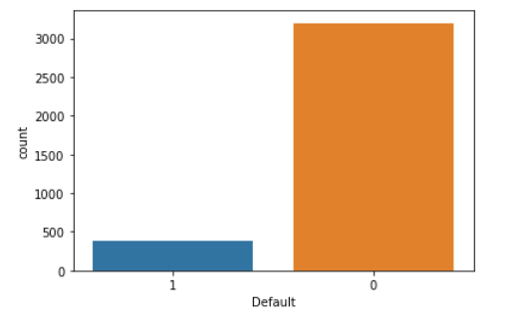
That means around 11% of the companies are default.
OUTLIERS TREATMENT
Let’s check the outliers.
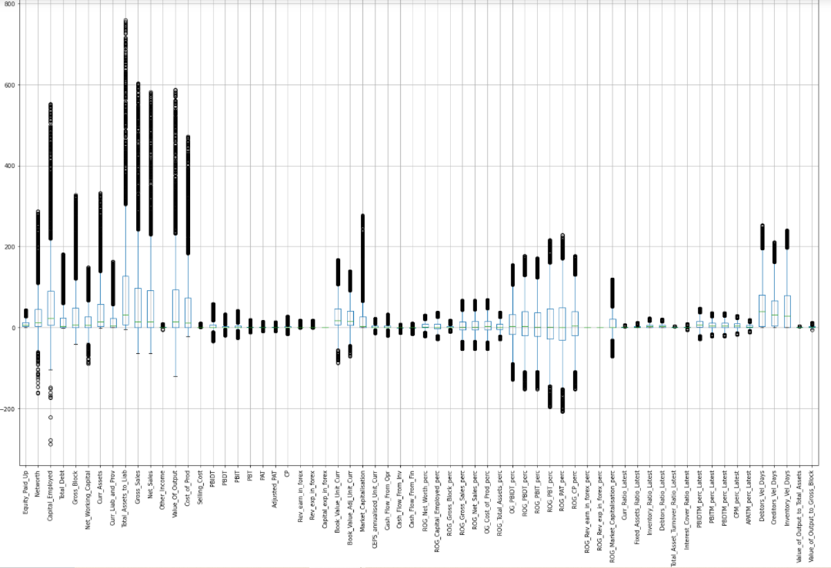

Every variable has outliers.
Outliers are not good for any regression model.
We are using Logistic Regression for model building, so outliers should be treated properly.
We will first check the number of outliers.
We will be using Inter Quartile Range method to check outliers.
We have dropped country code (Co_Code) and country name (Co_Name) because they are not very useful for our model building.

Let’s look at number of outliers in each column.
- Networth_Next_Year 676
- Equity_Paid_Up 448
- Networth 650
- Capital_Employed 596
- Total_Debt 583
- Gross_Block 540
- Net_Working_Capital 625
- Curr_Assets 577
- Curr_Liab_and_Prov 581
- Total_Assets_to_Liab 574
- Gross_Sales 554
- Net_Sales 556
- Other_Income 603
- Value_Of_Output 559
- Cost_of_Prod 560
- Selling_Cost 605
- PBIDT 671
- PBDT 815
- PBIT 720
- PBT 941
- PAT 959
- Adjusted_PAT 954
- CP 816
- Rev_earn_in_forex 738
- Rev_exp_in_forex 693
- Capital_exp_in_forex 694
- Book_Value_Unit_Curr 485
- Book_Value_Adj_Unit_Curr 486
- Market_Capitalisation 639
- CEPS_annualised_Unit_Curr 602
- Cash_Flow_From_Opr 801
- Cash_Flow_From_Inv 876
- Cash_Flow_From_Fin 1005
- ROG_Net_Worth_perc 747
- ROG_Capital_Employed_perc 572
- ROG_Gross_Block_perc 830
- ROG_Gross_Sales_perc 671
- ROG_Net_Sales_perc 667
- OG_Cost_of_Prod_perc 675
- ROG_Total_Assets_perc 483
- OG_PBIDT_perc 611
- ROG_PBDT_perc 628
- ROG_PBIT_perc 616
- ROG_PBT_perc 611
- ROG_PAT_perc 598
- ROG_CP_perc 637
- ROG_Rev_earn_in_forex_perc 1317
- ROG_Rev_exp_in_forex_perc 1615
- ROG_Market_Capitalisation_perc 497
- Curr_Ratio_Latest 565
- Fixed_Assets_Ratio_Latest 495
- Inventory_Ratio_Latest 375
- Debtors_Ratio_Latest 371
- Total_Asset_Turnover_Ratio_Latest 201
- Interest_Cover_Ratio_Latest 725
- PBIDTM_perc_Latest 595
- PBITM_perc_Latest 717
- PBDTM_perc_Latest 695
- CPM_perc_Latest 720
- APATM_perc_Latest 933
- Debtors_Vel_Days 398
- Creditors_Vel_Days 391
- Inventory_Vel_Days 262
- Value_of_Output_to_Total_Assets 150
- Value_of_Output_to_Gross_Block 481

So we can see that every variable has outliers in it.
So first we will check how many total outliers present.
After calculation, the total outliers in the dataset are: 42031
Treating these many outliers by just capping and flooring is not a good idea.
Because that simply means that we are manipulating the actual data.
So here first we will replace these outliers with Nan values (missing values) and then we will treat those missing values all at once.

MISSING VALUES TRAETMENT
So after replacing outliers with the missing values, we will see now how many total missing values including outliers are present.
Total missing values including outliers: 42149
Now let’s see the heat map for missing values.
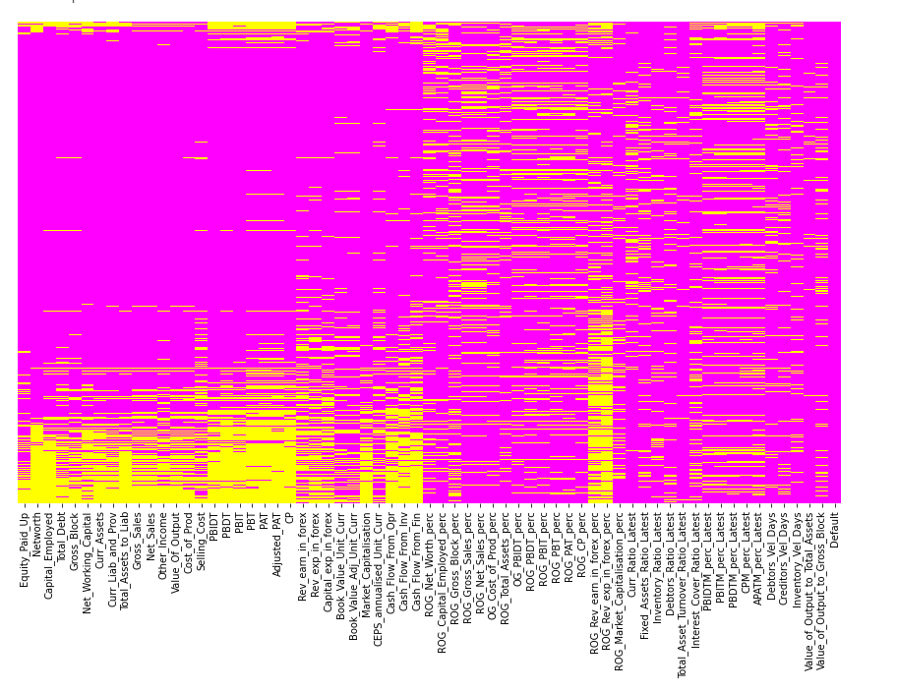
Here Yellow color indicates the missing data points which is clearly visible in the above heat map.
There are so many missing data points in the dataset.
But before moving further, we will also check the missing data in each row.
Because if some company has more number of missing data then we cannot put those fields manually or by just imputing some random mean or median, because in the end that leads to the model failure and cause error.
So, after checking the row wise missing data, we found that so many records has missing data in it, which is not good for further analysis.
We will only use those records (rows) where number of missing data is less than 10%.
After calculation it has found out that 1460 records out of 3586 are having more than 90% of the data available in their respective data fields.
And If we calculate the percentage of how many columns have missing data:

ROG_Rev_exp_in_forex_perc 0.45
ROG_Rev_earn_in_forex_perc 0.37
Cash_Flow_From_Fin 0.28
PAT 0.27
Adjusted_PAT 0.27
PBT 0.26
APATM_perc_Latest 0.26
Cash_Flow_From_Inv 0.24
ROG_Gross_Block_perc 0.23
CP 0.23
PBDT 0.23
Cash_Flow_From_Opr 0.22
ROG_Net_Worth_perc 0.21
Rev_earn_in_forex 0.21
Interest_Cover_Ratio_Latest 0.20
CPM_perc_Latest 0.20
PBIT 0.20
PBITM_perc_Latest 0.20
PBDTM_perc_Latest 0.19
Capital_exp_in_forex 0.19
Rev_exp_in_forex 0.19
OG_Cost_of_Prod_perc 0.19
ROG_Gross_Sales_perc 0.19
PBIDT 0.19
ROG_Net_Sales_perc 0.19
Networth 0.18
Market_Capitalisation 0.18
ROG_CP_perc 0.18
ROG_PBDT_perc 0.18
Net_Working_Capital 0.17
ROG_PBIT_perc 0.17
ROG_PBT_perc 0.17
OG_PBIDT_perc 0.17
Selling_Cost 0.17
Other_Income 0.17
CEPS_annualised_Unit_Curr 0.17
ROG_PAT_perc 0.17
PBIDTM_perc_Latest 0.17
Capital_Employed 0.17
Total_Debt 0.16
Curr_Liab_and_Prov 0.16
Curr_Assets 0.16
Total_Assets_to_Liab 0.16
ROG_Capital_Employed_perc 0.16
Curr_Ratio_Latest 0.16
Cost_of_Prod 0.16
Value_Of_Output 0.16
Net_Sales 0.16
Gross_Sales 0.15
Gross_Block 0.15
ROG_Market_Capitalisation_perc 0.14
Fixed_Assets_Ratio_Latest 0.14
Book_Value_Adj_Unit_Curr 0.14
Book_Value_Unit_Curr 0.14
ROG_Total_Assets_perc 0.13
Value_of_Output_to_Gross_Block 0.13
Equity_Paid_Up 0.12
Debtors_Vel_Days 0.11
Creditors_Vel_Days 0.11
Inventory_Ratio_Latest 0.10
Debtors_Ratio_Latest 0.10
Inventory_Vel_Days 0.10
Total_Asset_Turnover_Ratio_Latest 0.06
Value_of_Output_to_Total_Assets 0.04

So from the above calculation we have found out that the below columns have the most number of missing data, which does help us in any way and we must need to remove such columns from our dataset for further analysis so that we can build our model successfully.
So we have decided to drop those columns which has more than 25% of the missing data.
Below are the columns with more than 25% of the missing data.
'ROG_Rev_exp_in_forex_perc' has 45% missing data.
‘ROG_Rev_earn_in_forex_perc' has 37%.
'Cash_Flow_From_Fin' has 28%.
'PAT' has 27%.
'Adjusted_PAT' has 27%.
'PBT' has 26%.
'APATM_perc_Latest' has 26%.
So, after removing these columns we have only 58 columns available.

SCALING
First separating the predictors and response.
Importing StandardScaler from sklearn.preprocessing
Imputing the other remaining missing values using KNN Imputer taking n_neighbors = 10
After treating the outliers and missing values, let’s again look at the correlation.
Here is the heat map.
The light green color indicates higher correlation between the columns while the dark blue color indicates the low correlation between columns.

We can clearly see that the high correlation between few columns named, Equity paid up, Capital Employed, Gross Block, Current Assets, Total Assets to liabilities, Net sales, Value of Output and selling cost.

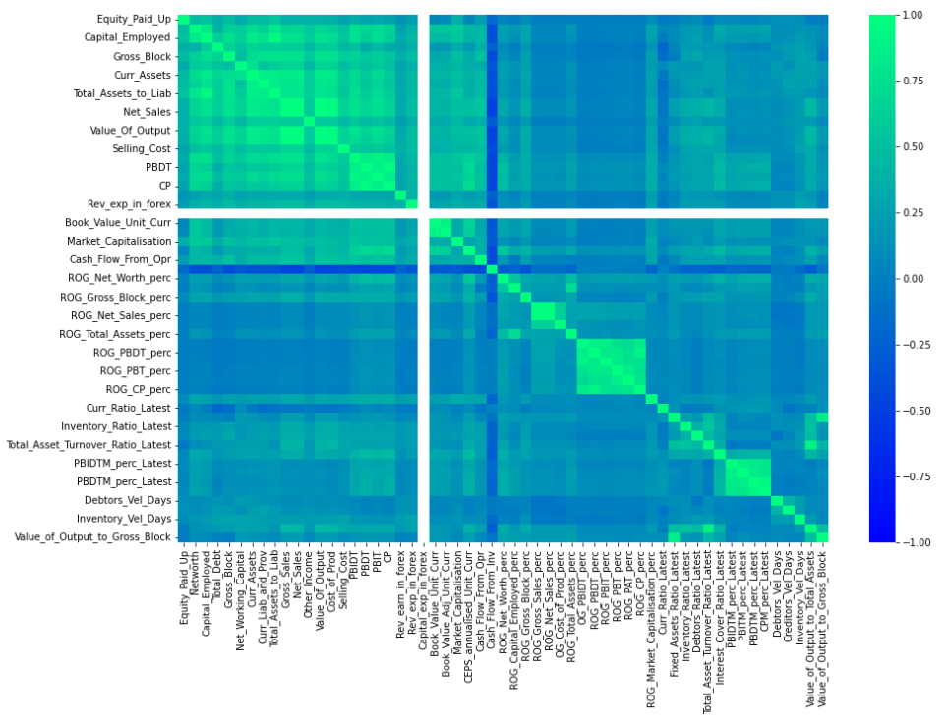

SPLIT THE DATASET INTO TRAIN AND TEST
Splitting the dataset into test and train in 67:33 ratio with random_state = 42.
After splitting, train set has 2402 rows which is the 67% and test set has 1184 records which is 33% of the total dataset.
We are using Logistic Regression as a model with Recursive Feature Elimination (RFE) to get the best ranked features for our model building.
Getting the n_features from selector.
Assigning the rank to the features.
Checking the features with Rank 1.
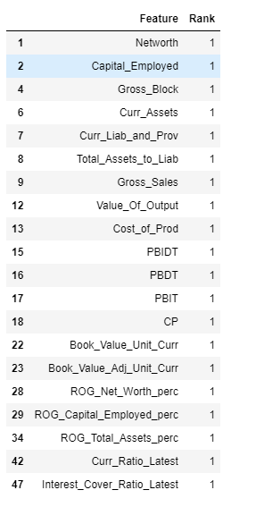

Validating the model on train and test:
Confusion matrix for train set:
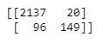
Classification Report for train set:
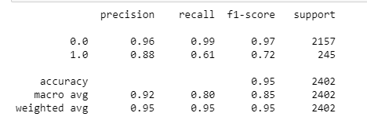
Confusion Matrix for test set:
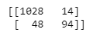
Classification Report for test set:
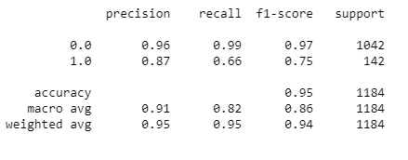

Recall is not good, due to the imbalance in the data.
We will balance the data using over sampling technique - SMOTE.
Imported SMOTE.

Classification report after applying SMOTE.
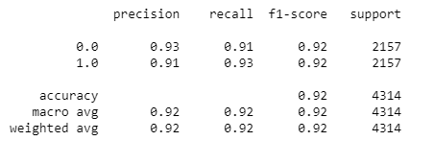
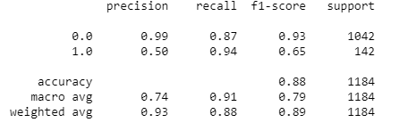
Now the recall has improved.
CONCLUSION
- After looking at the recall and precision for the above model after applying SMOTE we can say that the results are now improved.
- We got better recall of 94% for 1, which means 94% of the actual value of defaults are the right prediction.
- Precision of 50% means 50% of the predicted defaults are actual.
____________________________________________________________

